**“Epidemic Simulator”**

In Partial Fulfillment of the Requirements in the Major Subject

**Modeling and Simulation**

**Submitted by:**

Ambrocio, Angelica

 Bella, Mary Joy

Bolo, Wenzel Andrei

 Galaites, Gea

 Macaraig, Kate

Munsayac, Malacai Angelo

 Surigao, Ioshua Jericho

**Submitted to:**

Prof. Angelica P. Payne, LPT  
**Modeling and Simulation Adviser**

December 2022

**TABLE OF CONTENTS**

COVER PAGE               1

FLOW CHART            3

INSTRUCTION MANUAL          4-14

**FLOWCHART**

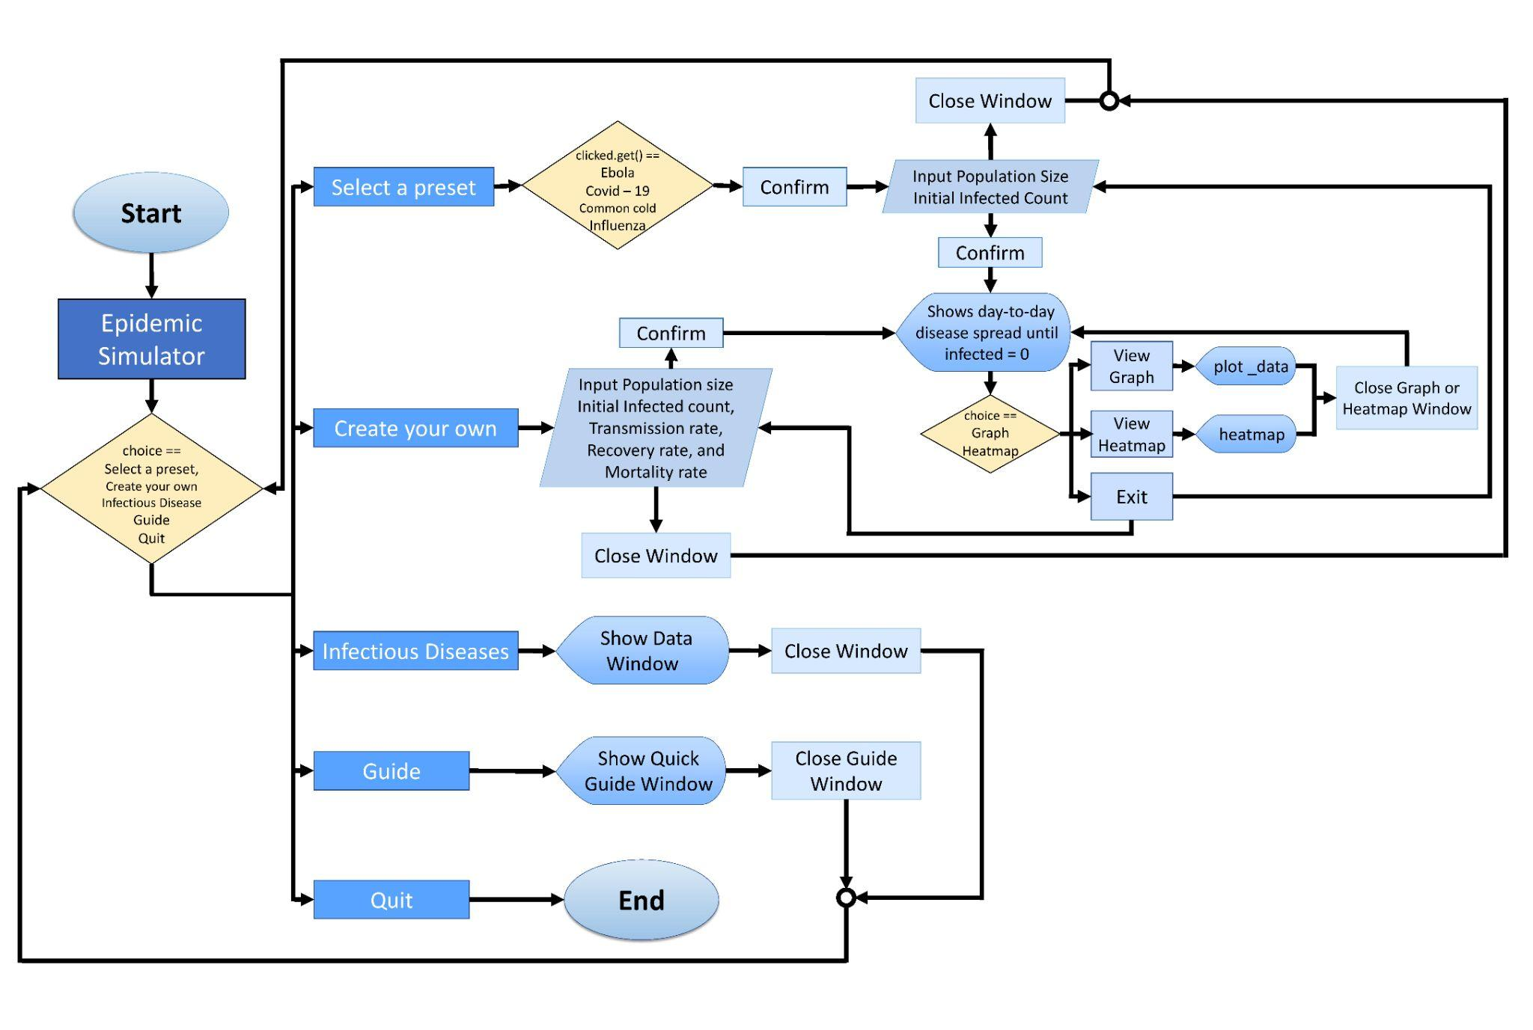

**INSTRUCTIONAL MANUAL**

**Epidemic simulator is an application which allows the user to stimulate the spread of diseases and to make a prediction of how long it will take to spread the virus. It also shows the possible outcome of patients that will recover and possible deaths that may occur.**

1. **Interface  
   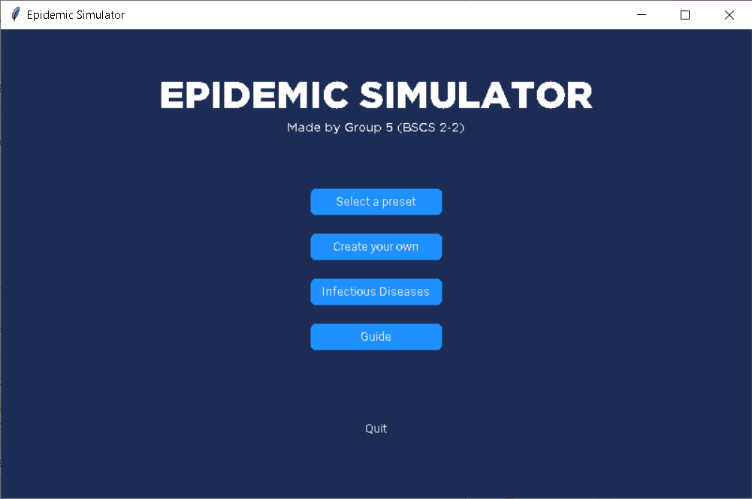**
2. **Simulation**
3. **Select a preset**

By selecting the “Select a preset” button, a small window will be opened, containing a drop list of choices. Once a user is able to confirm a choice, the “Simulation” window will request an input from the user.  
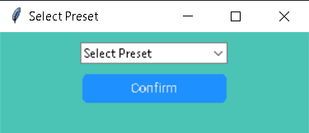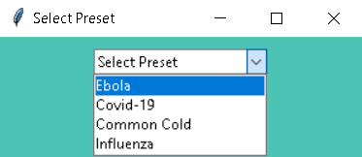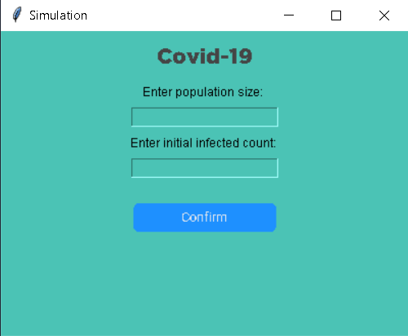

1. **Create your own**

The user will instantly be directed to the “Simulation” window where transmission, recovery, and mortality rate will additionally be requested as an input.  
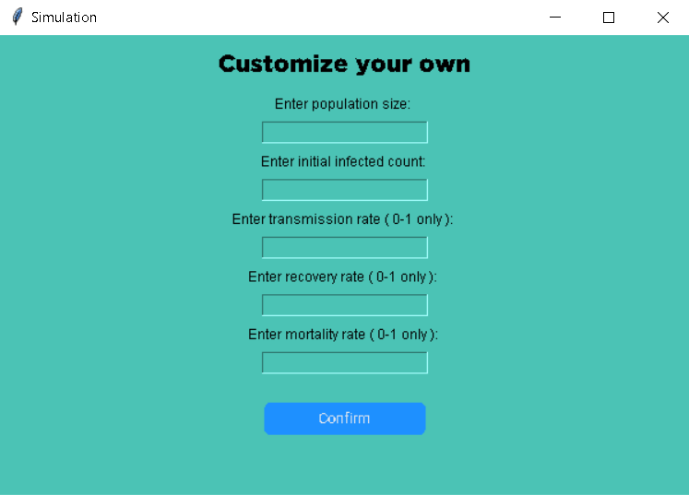

1. **Results**

Once all necessary data is gathered from either of the two choices: “Select and preset” and “Customize your own”, the “Results” window will follow. This contains the day-to-day disease spread that stops when infected count is 0. The user will also be given a choice to either view the graph of results or exit the window. 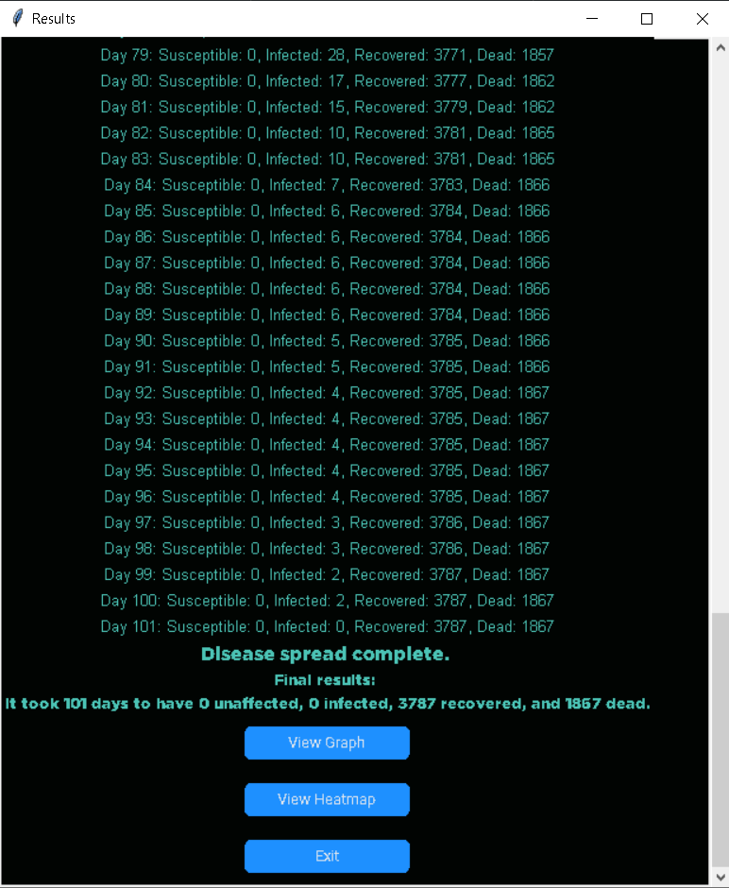

1. **Graph**

If the user chooses to view the graph, the “Graph” window will open.  
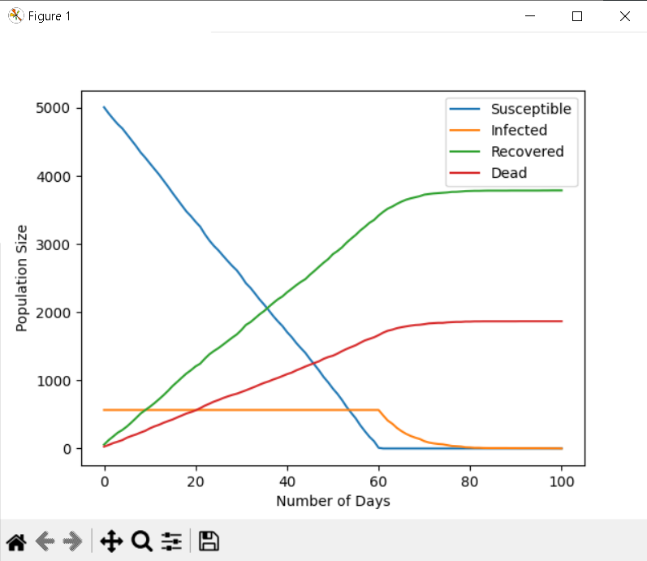

1. **Heatmap**

If the user chooses to view the Heatmap, the “Heatmap” window will open.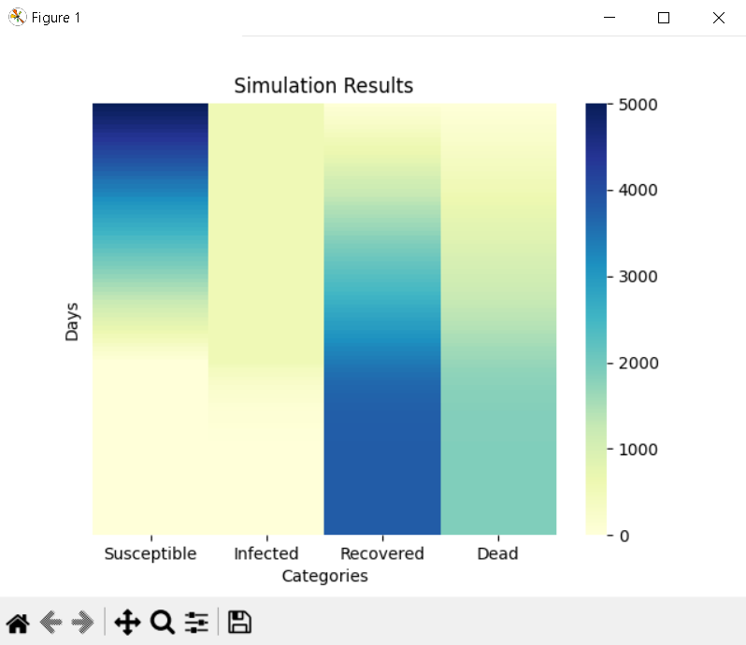

1. **Infectious Diseases**

In this window, the disease presets will be displayed along with their description and initialized variables on transmission, recovery, and mortality rate.  
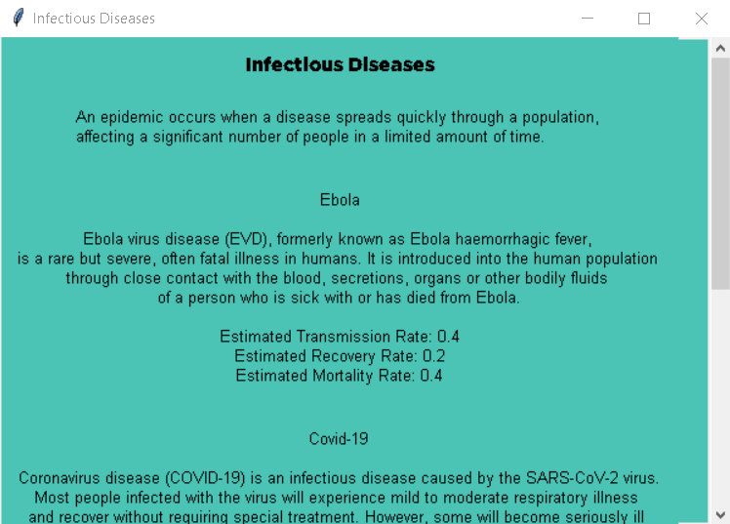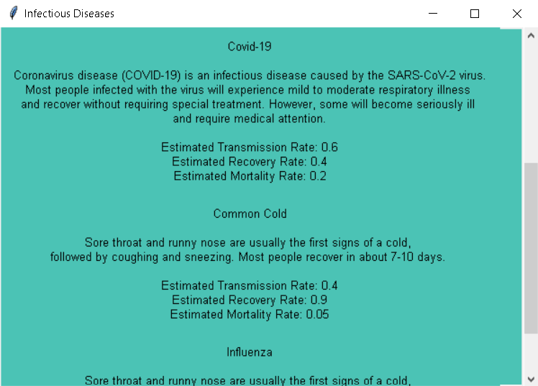

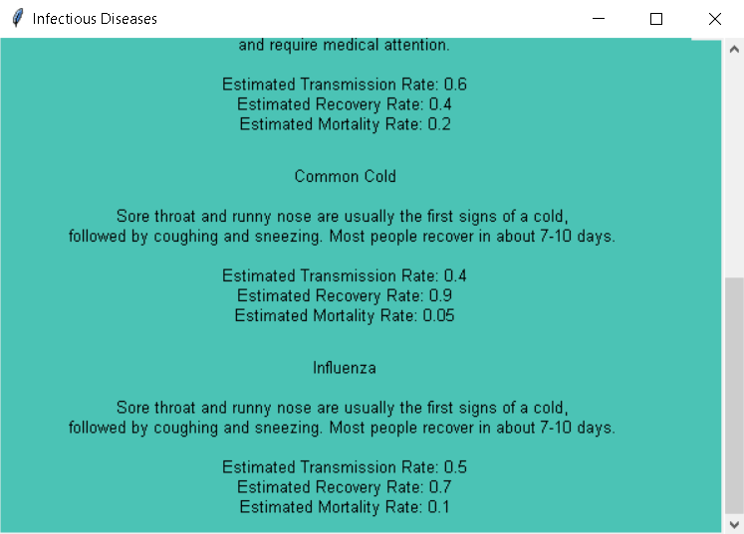

1. **Guide**

This window will display a quick guide on some of the terminologies used in the simulation: transmission, recovery, and mortality rate.  
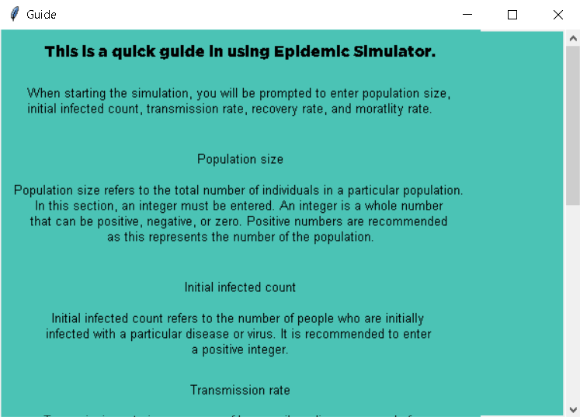

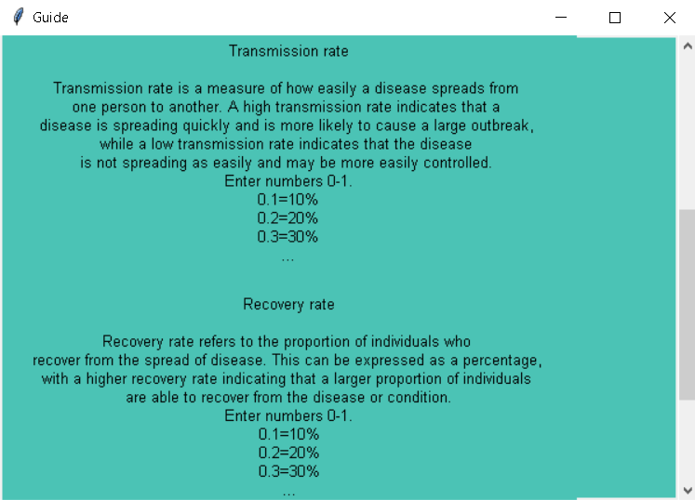

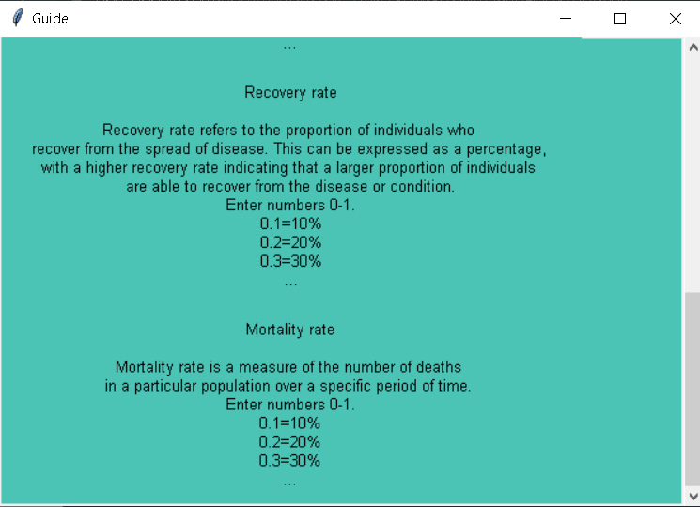

1. **Quit**

The “quit” button on the menu will terminate the program.